**HMR Institute of Technology & Management, New Delhi, India**



**CodeBreak Event   
(IEEE HMRITM, Emblazon 2019)**

**UPRISERS   
<AMAN SRIVASTAVA**

**ABHISHEK SAINI**

**ABHINAV K GUPTA**

**MUSKAN MALHOTRA>  
<HMRITM>  
<SMART HOSPITAL>**

**In Association with:** [**GitHub Inc.**](https://github.com)

**Problem Statement**(*Includes your inspiration of idea and proper description of problem that you are going to solve)

**As we all know that the database management in hospitals now a days in rural areas are solely dependent on file system. It may lead to misplacement of data and one of the major problem in government hospitals is that there are long waiting hours in these hospitals which leads to affliction of the patient’s need.**

**Introduction**(In this section, you will include brief introduction to your project with pros and cons & how your project resembles with the theme you selected)

**In TODAY SCENARIO,IT IS COMMONLY OBSERVED THAT HOSPITALS ARE OVERCROWDED WITH NUMBER OF SUFFERING PATIENTS SO THE QUESTION ARRISES THAT WHERE DOES THE PROBLEM LIE. CLEARLY, THIS PROBLEM OCCURS DUE TO LACK OF A PROPER DATABASE AND MANGEMENT OF THE CROWD.**

**Proposed/Working Model**

(Under this section, you will have to include the detailed description of your developed project with screenshots of output/software/website pages & **NO CODE**)

**OUR PROJECT AIMS TO PROVIDE SIMPLE AND EFFICIENT INTERFACE SO THAT WE CAN DELIVER UTMOST PRODUCTIVITY TO THE MAJORITY OF PATIENTS.**

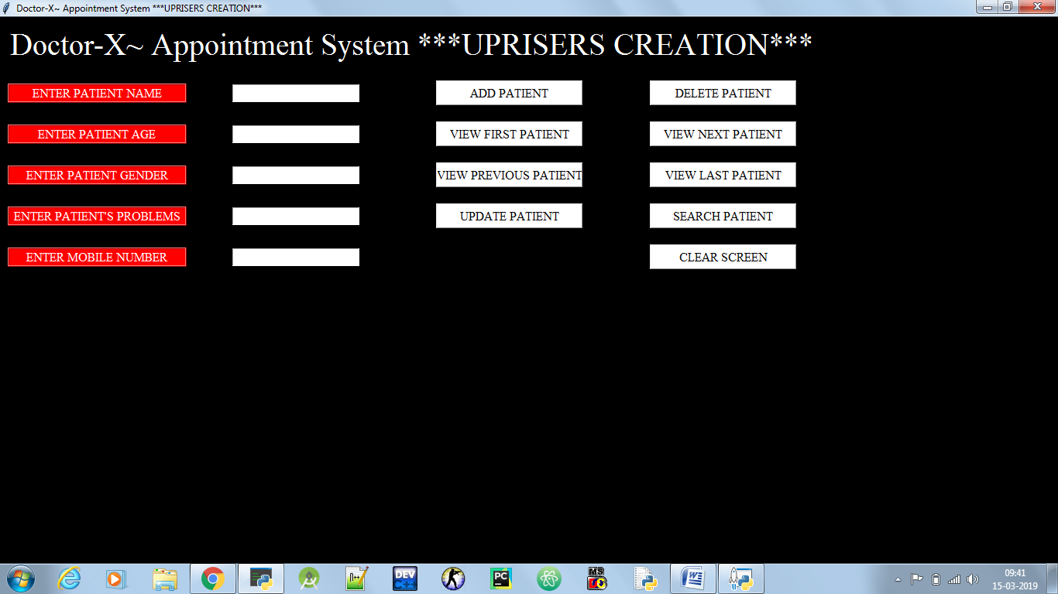

**Conclusion**(Under this section, you will have to include the outcome of your project with detailed pros and cons)

* **EFFICIENT METHODS OF CROWD MANAGEMENT**
* **SUITABLE ADDRESSING OF THE PATIENT’S PROBLEM**
* **EASY DATABASE MANAGEMENT**
* **CONVINENCE TO THE PATIENTS ARE PROVIDED**

**Future Scope**(In this section, you will have to mention the future aspects or advancement that you are going to make and what will be the outcome if those advancements will be done)

* DIGITALIZE METHOD OF APPOINTMENTS
* REDUCTION IN WAITING TIME
* JOB OPPURTUNITIES INCREASED
* PATIENTS WILL GET PROPER TREATMENT AND DOCTORS